**Experiment 16:** Demonstrate Infrastructure as a Service (IaaS) by creating a resources group using a Public Cloud Service Provider (Azure), configure with minimum CPU, RAM, and Storage.

Step 1: Create a Resource Group.

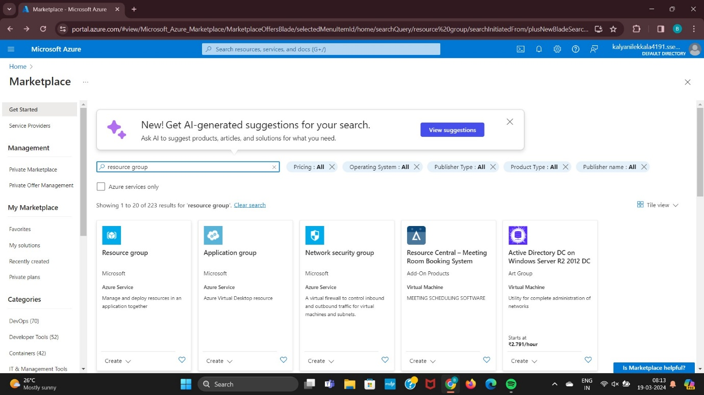

Step 2: Click on Create Option.

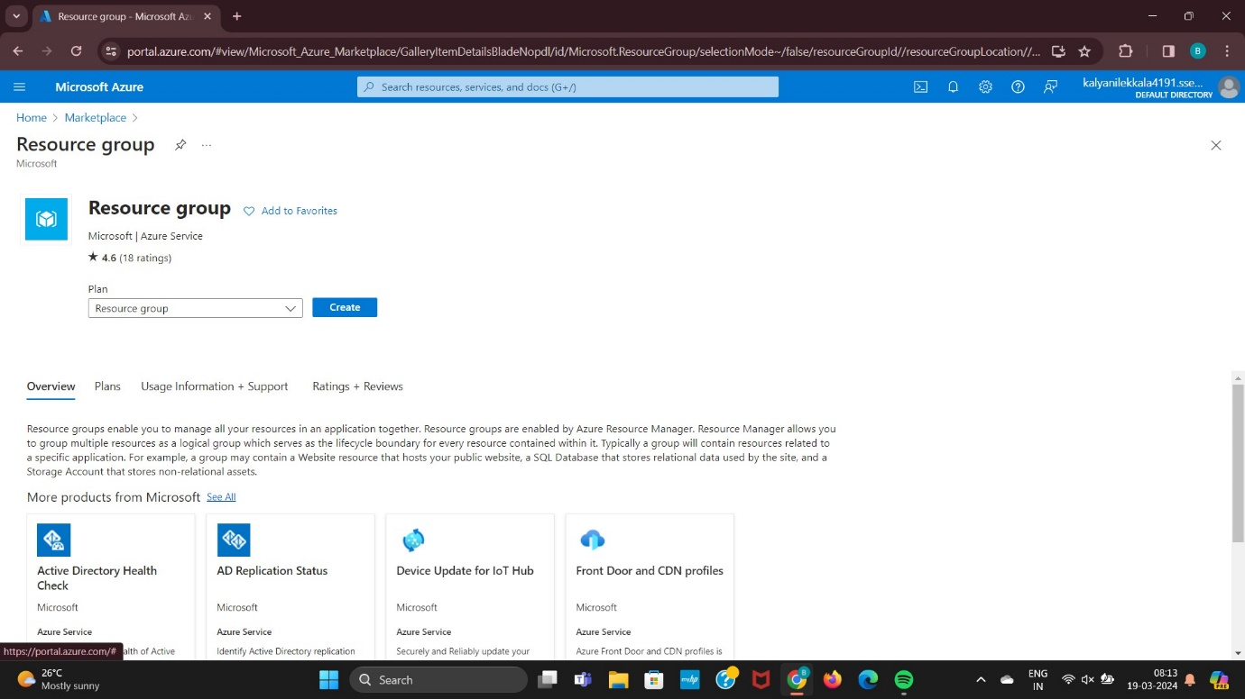

Step 3: Give Resource Name and Give Region Name.

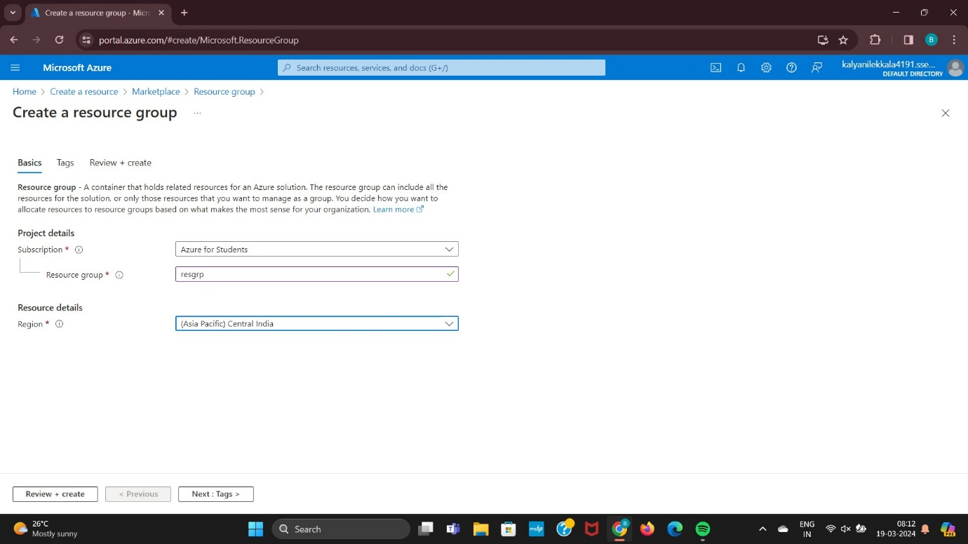

Step 4: Enter Name and Value.

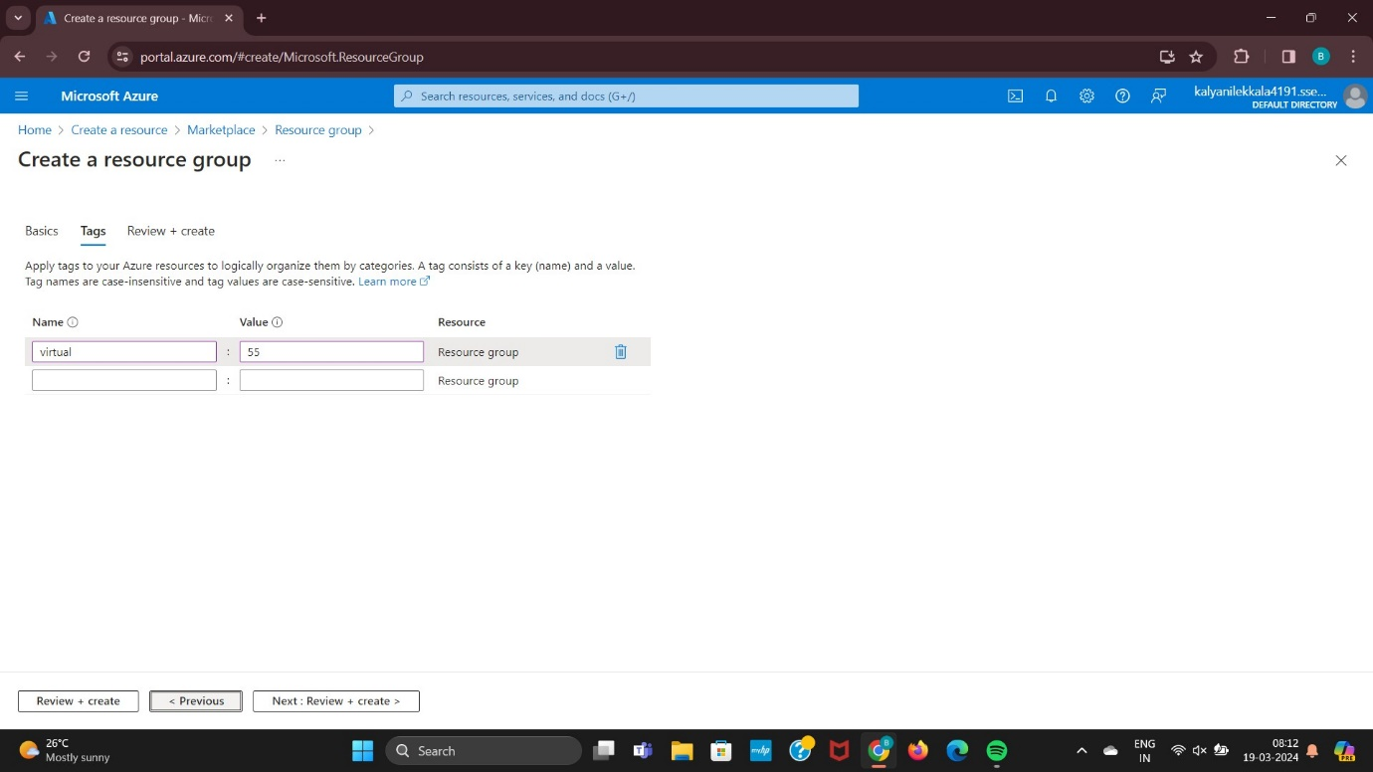

Step 5: Finally Validation Passed Created.

